**FOOD DELIVERY System**

TEAM MEMEBERS :

1.Vinutha A G

2.Shivani Patel G T

3.Kusuma N T

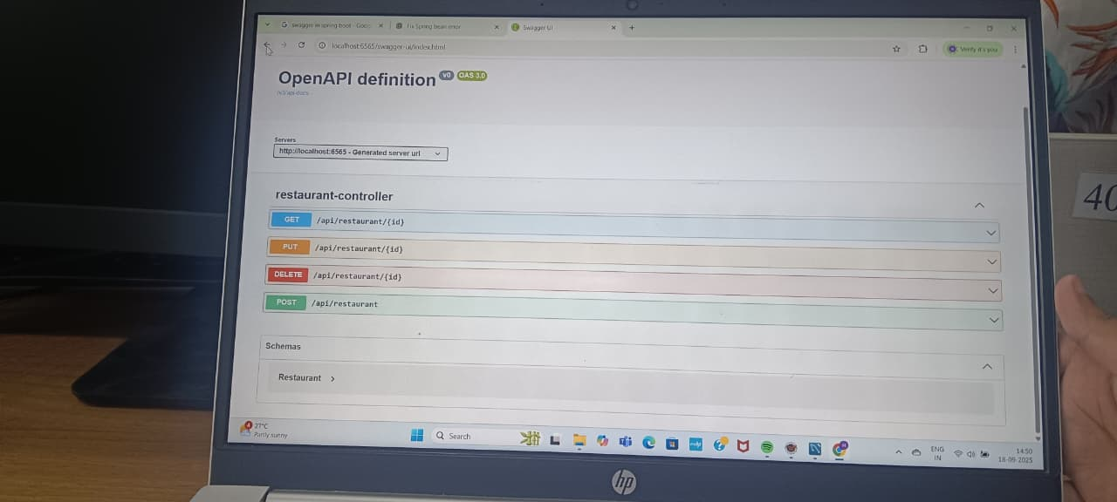

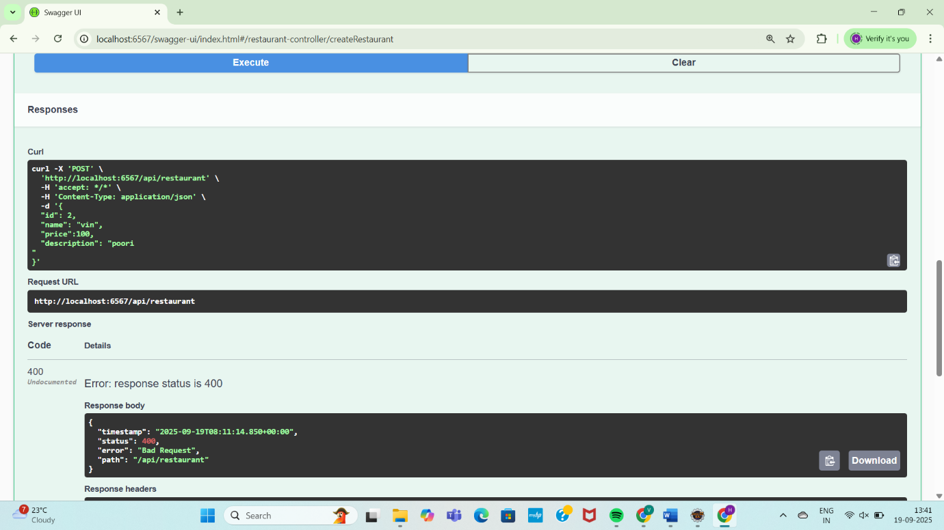

MYSQL WORKBENCH SCREENSHOT:-

